UC760 Maintenance Common Domain Tables

**General description**

Use case 760 addresses, among other things, the maintenance of the common domain tables. The tables shall be maintained manually by the functional manager by means of the Maintenance Domain Table function. The maintenance functionality of one domain table resembles that of other tables.

To shorten this document only for one or two instances of each group an extensive specification is given. In case of the remaining tables we will refer to this specification and focus on the specific properties of the domain table on hand.

# Version control

|  |  |  |  |
| --- | --- | --- | --- |
| Version | Date | Status | Version Dave Oberweis |
| 0.4 | 28-02-2019 | Draft | Initial version |
| 0.5 | 29-09-2020 | Draft | Update with new wireframes and general user editing flow. |
| 1.0 | 25-10-2020 | Final | Included all items discussed in calls on 22-23 Oktober.  Approved by customer on 16/11/2020  In case of contradictions between this v.1.0 version and any previous documentation this version is leading |

# Structure of the document

[1 Version control 1](#_Toc54545480)

[2 Structure of the document 1](#_Toc54545481)

[3 Common Domain Tables 1](#_Toc54545482)

[4 Maintenance Function General Setup 2](#_Toc54545483)

[5 User Interface Controls 3](#_Toc54545484)

[6 General metadata columns 3](#_Toc54545485)

[7 Region model 3](#_Toc54545486)

[7.1 Centrale (Centre) maintenance screen 4](#_Toc54545487)

[7.2 Gebied (Area) maintenance screen. 4](#_Toc54545488)

[7.3 Superblok 5](#_Toc54545489)

[7.4 Superblok - Blok 6](#_Toc54545490)

[7.5 Object 7](#_Toc54545491)

[7.6 CBS-partner 8](#_Toc54545492)

[7.7 Zeeschip type 9](#_Toc54545493)

[7.8 Binnenvaartschip type 10](#_Toc54545494)

[7.9 Authorisatie CBS Bericht 11](#_Toc54545495)

[7.10 Authorisatie ERINOT Bericht 11](#_Toc54545496)

[7.11 Prioriteit Bron 12](#_Toc54545497)

[7.12 Data Element Prioriteit 13](#_Toc54545498)

[7.13 Enumeraties 14](#_Toc54545499)

[7.14 Timer 15](#_Toc54545500)

# Common Domain Tables

The table here under shows the tables to be maintained by the present function.

|  |  |
| --- | --- |
| Dutch table name | Table name |
| Centrale | OPERATION\_CENTRE |
| Gebied | WORK\_AREA (and |
| Superblok |  |
| Superblok - Blok |  |
| Object | OBJECT |
| CBS-partner | CBS\_PARTNER |
| Zeeschip type | SEASHIP\_TYPE |
| Binnenvaartschip type | BASE\_TYPE |
| Authorisatie CBS Bericht |  |
| Authorisatie ERINOT Bericht |  |
| Prioriteit Bron | PRIORITY\_SOURCES |
| Data Element Prioriteit | PRIORITY\_DETAILS\_CHANNELS (PRIORITY\_SOURCES, PRIORITY\_DETAILS) |
| Enumeraties | MASTER\_VALUE\_ENUMERATIONS |
| Timer |  |

Table 1; List of maintained tables

# Maintenance Function General Setup

The user interface of the Common Domain table Maintenance Function consists of two window panes:

1. Table of contents, showing the domain tables. The user selects the current (to be edited) Domain table – one at a time.
2. Table window pane, showing in tabular form the records of the current Domain table. In this window the user can add new records, and delete and edit existing records. Updates may be entered into the table or in an edit dialogue. Edit dialogues are used to enter child records.

The width of the window panes can be adjusted, to maximize the available screen space for the action.

Columns referencing a column of another table are entered by means of a drop down select control. This also applies for columns with a fixed domain, for instance the STATUS\_CODE column which can be “A” for actual or “E” for ended.

For a number of domain tables a sketch of the required windows and dialogues is given. In case of domain tables where this would just be a repeat, we will just refer to corresponding examples.

For each domain table a table is given holding the specification of the next properties:

|  |  |
| --- | --- |
| Nr: | Sequence number. |
| Data-item: | Name of the column/field of the user interface window of dialogue. |
| Edit: | Column is editable or not editable. |
| Format: | Type and length of the column or field. |
| Req: | The column is required or may be empty. |
| Specification: | Validation rules for the column/field or combination, references to other tables. |
| Field: | Corresponding domain table column. |

The user interface always reflects the database structure, i.e. the relations between tables, but instead of showing the referencing column(s), the so-called foreign key, which sometimes may be of a technical nature, another, meaningful attribute may be displayed. In the specification table under the header ‘specification’ such references are clarified: the technical foreign key is mentioned explicitly.

In case the user interface description and the database design do not match completely, the database design prevails.

# User Interface Controls

|  |  |
| --- | --- |
| **Control** | **Explanation** |
| **þ** | The item is selected. |
| o | The item is not selected. |
| **¤** | Radio button, exactly one of the items shown is selected. |
| ¡ |
|  | Opens the dialogue in order to edit the alphanumeric properties of the selected record/entity. |
| C:\Users\Dave\Documents\DAO\Projecten actueel\DAO1701-ARS-SRK\Layout buttons\confirm - button.png | Accepts the changes made and closes the function or dialogue. |
| C:\Users\Dave\Documents\DAO\Projecten actueel\DAO1701-ARS-SRK\Layout buttons\Cancel.png | Rolls back the changes made and closes the function or dialogue. |
| C:\Users\Dave\Documents\DAO\Projecten actueel\DAO1701-ARS-SRK\Layout buttons\Plus - button.jpg | Adds a new record/entity. |
|  | Deletes the selected record/entity. |
| C:\Users\Dave\Downloads\1490116212_icon-arrow-up-b.png | Moves the selected record/entity one place up. |
| C:\Users\Dave\Documents\DAO\Projecten actueel\DAO1701-ARS-SRK\Layout buttons\1490116429_icon-arrow-down-b.png | Moves the selected record/entity one place down. |

# General metadata columns

Each common domain table has the next metadata fields, which we will not mention at every domain table.

|  |  |  |  |  |  |  |
| --- | --- | --- | --- | --- | --- | --- |
| 1 | Status | Yes | char(1) | Yes | Lookup:  A = Actief (default)  N = Non-Actief | STATUS\_CODE |
| 2 | Bron | No | Integer | No | References: SOURCE.NAME corresponding with the Common Domain Table Maintenance Function | SOURCE\_NAME |
| 3 | D/T wijziging | Yes | dd-mm-yy hh:mm:ss | Yes | Default system time at time of change | LAST\_UPDATED\_TIME |
| 4 | D/T creatie | No | dd-mm-yy hh:mm:ss | Yes | System time at time of creation | CREATION\_TIME |

‘Tijd creatie’/CREATION\_TIME may possibly be dropped.

# Region model

The way the region entities are organized for SRK is described in in Figure 1; Region model for SRK. Here you see that a Traffic Centre (TC/Centrale) is responsible for one or more Areas (Gebied). In turn one or more Blocks (Blok) are assigned to an Area (no block is assigned to more than one Area. Also there exist SuperBlocks, these are groupings of blocks that are not assigned to a Centre but can be selected by the users to quickly see the connected Blocks.



Figure 1; Region model for SRK

## Centrale (Centre) maintenance screen

This screen is used to define the Centrale entity (Operations centre). Editing is done in the details area.

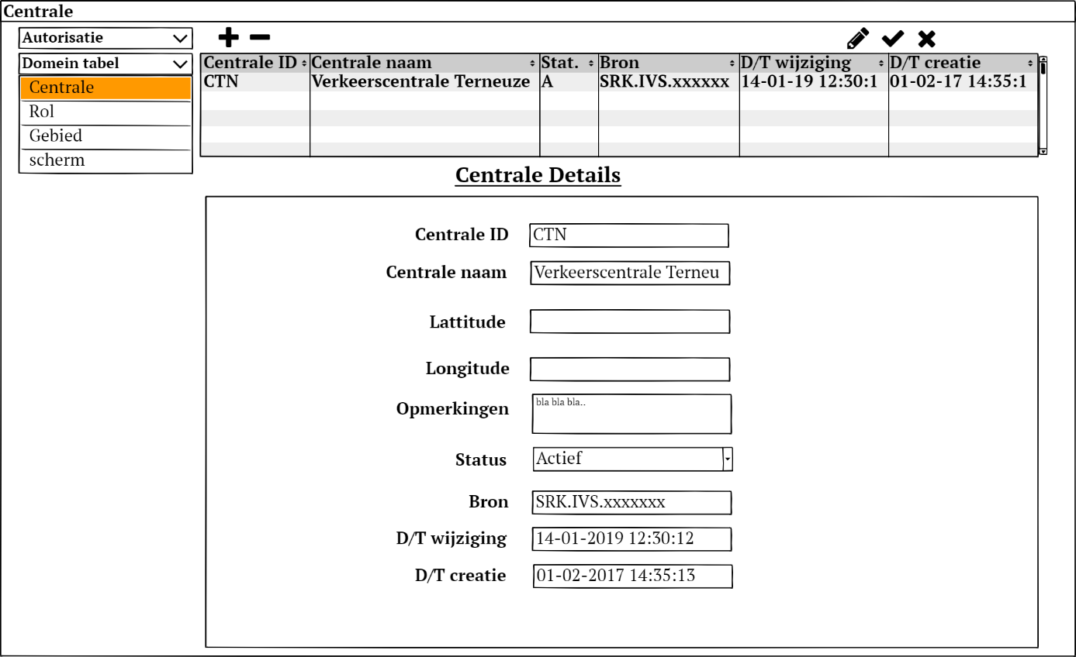

Figure 2; Centrale Domain data edit screen layout



Table 2; Centrale Domain data formats

## Gebied (Area) maintenance screen.

This screen is used to define the Area Entity, its relation to a traffic centre and what area is the default area for the traddic centre. Editing is done in the details area.

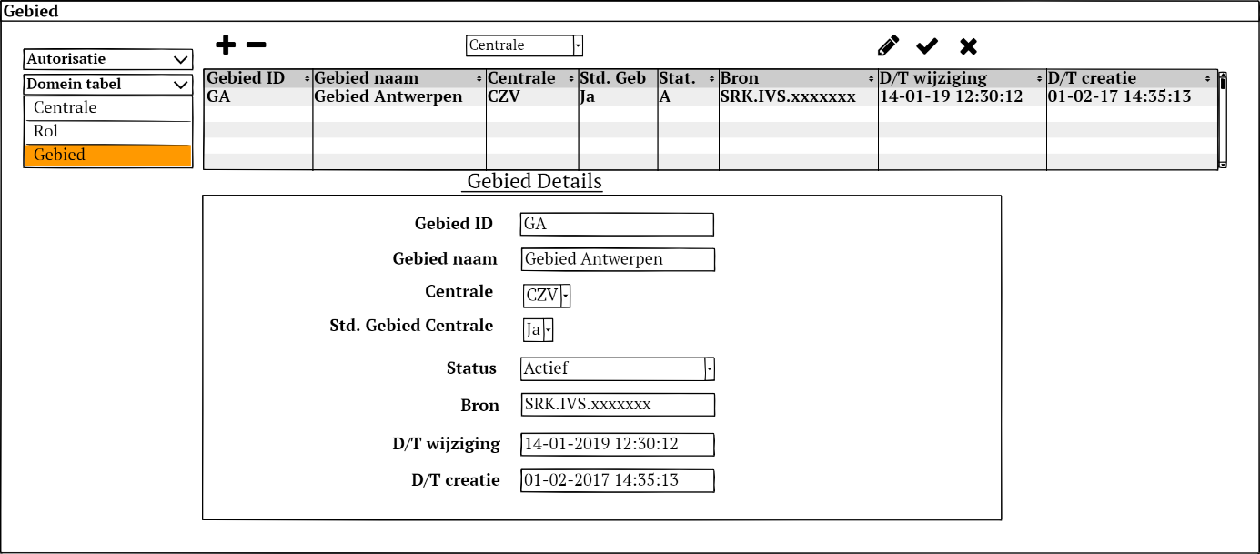

Figure 3; Gebied Domain data edit screen layout.



Table 3; Gebied Domain data formats

## Superblok

This screen is used to define the Superblock entities. Editing is done in the details area.

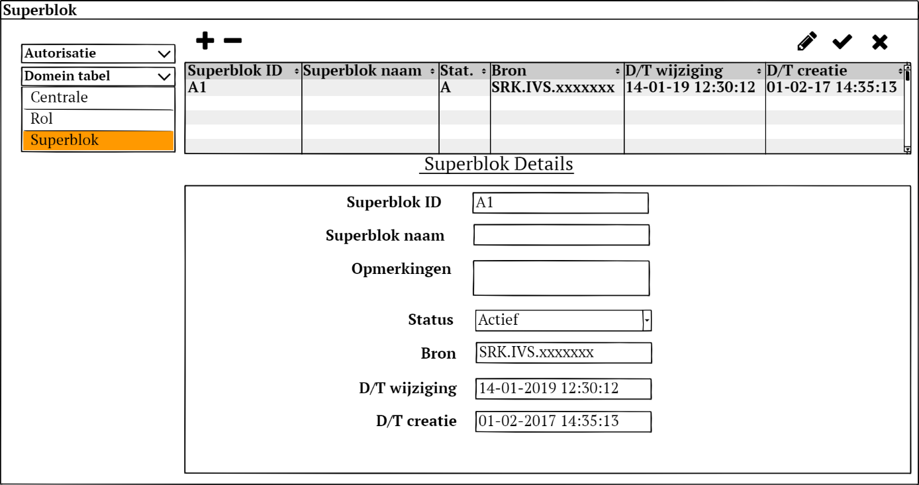

Figure 4; Superblok Domain data edit screen layout.



Table 4; Superblok Domain data

## Superblok - Blok

This screen is used to define the relation between superblocks and blocks. Each superblock can contain one or more blocks. Editing is done in the table area.

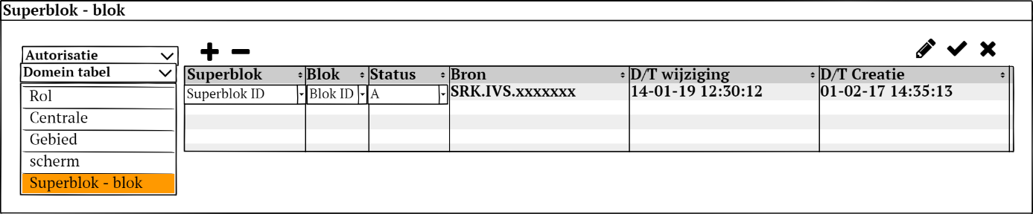

Figure 5; Superblok - Blok relationship Domain data edit screen layout.



Table 5; Superblok - Blok relationship Domain data format.

## Object

This screen is used to define the arributes of the Object entity. Besides these attibutes an object also contains geographic attibutes. These are managed in a separate Geo moddeling interface. Editing is done in the details area.

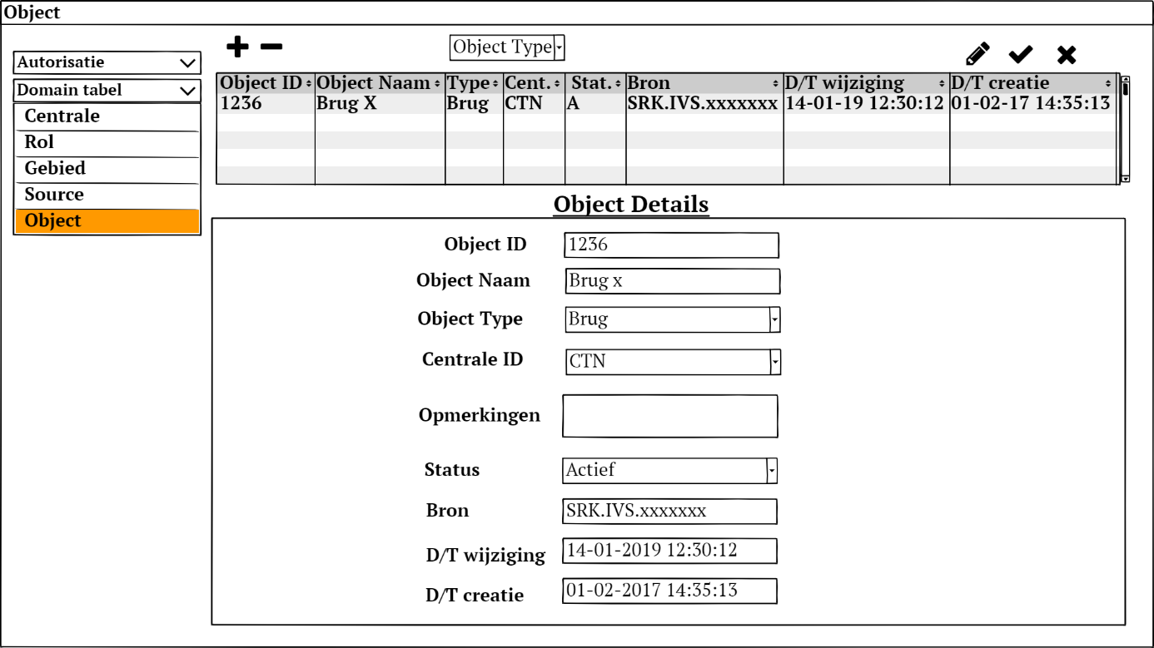

Figure 6; Object Domain data edit screen layout.



Table 6; Object Domain data format.

## CBS-partner

This screen is used to define the arributes of the CBS Partner entity. Editing is done in the details area.

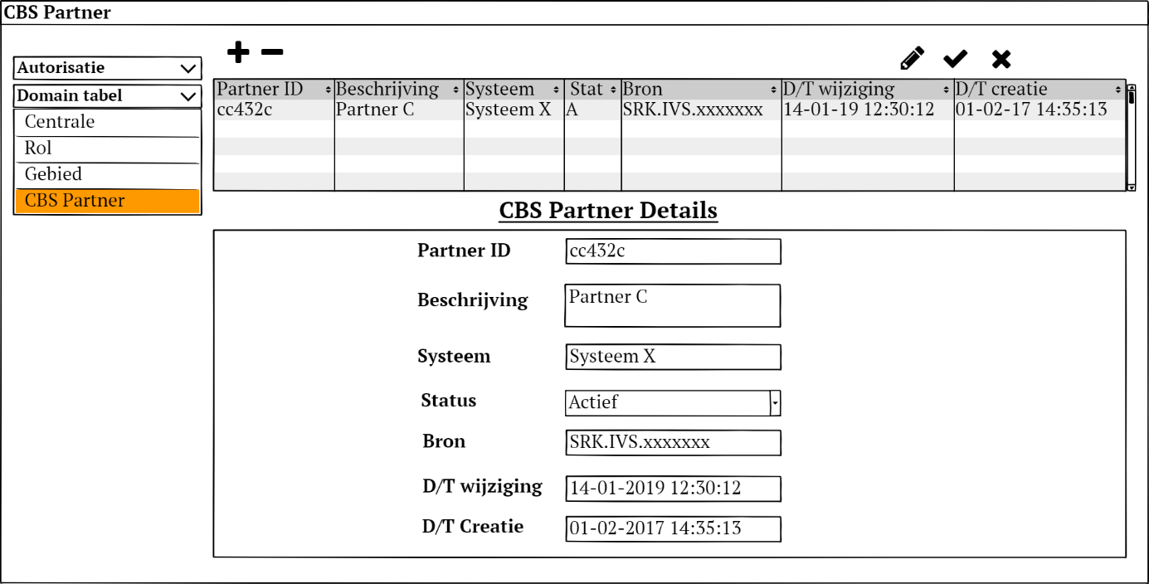

Figure 7; CBS Partner Domain data edit screen layout.



Table 7; CBS Partner Domain data format.

## Zeeschip type

This screen is used to define the attributes of the Seagoing ship Type entity. Editing is done in the details area

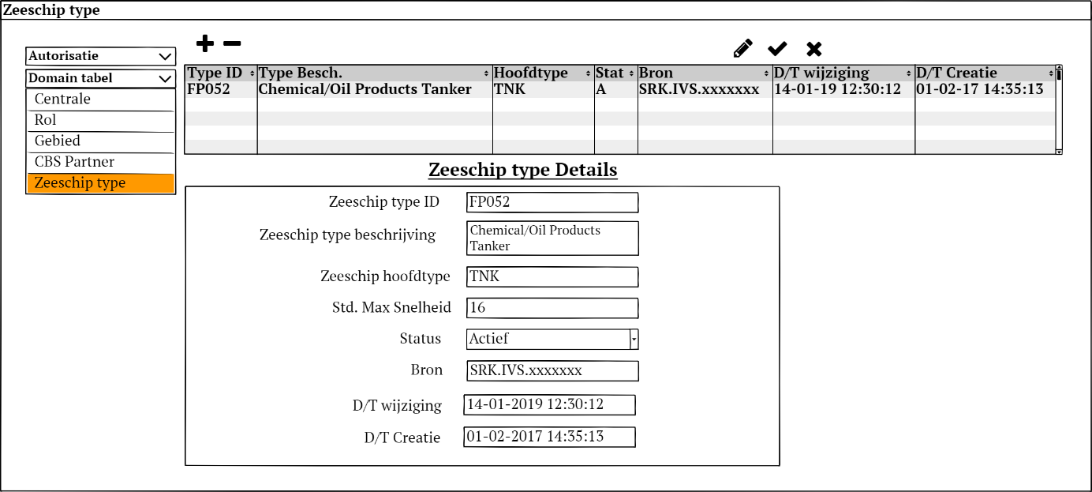

Figure 8; Seagoing ship Type Domain data edit screen layout.



Table 8; Seagoing ship Type Domain data format.

## Binnenvaartschip type

This screen is used to define the attributes of the Inland ship Type entity. Editing is done in the details area

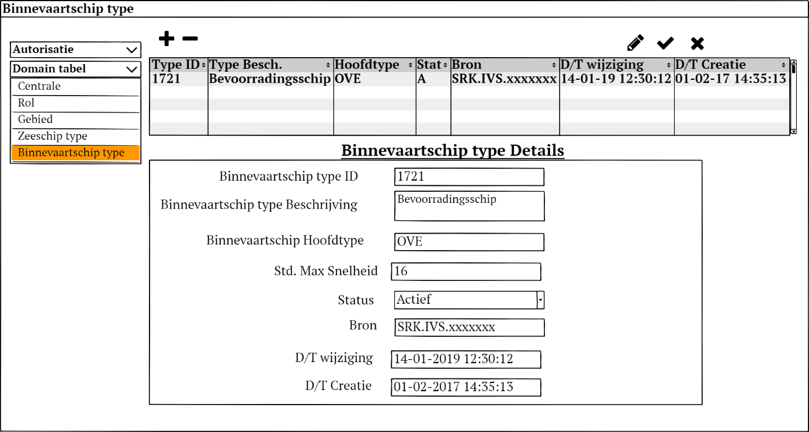

Figure 9; Inland ship Type Domain data edit screen layout



Table 9; Inland ship Type Domain data format.

## Authorisatie CBS Bericht

This screen is used to define for what Area what partner is authorised to CBS messages. Each Area - Partner should be unique (no duplicates). Editing is done in the table area.

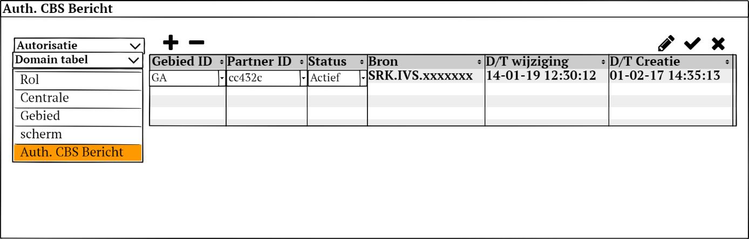

Figure 10; CBS Message Authorization Domain data edit screen layout



Table 10; CBS Message Authorization Domain data format

## Authorisatie ERINOT Bericht

This screen is used to define for what Geo point and direction what partner is authorised for ERINOT messages. Each Geo Point – Direction - Partner should be unique (no duplicates). Editing is done in the table area.

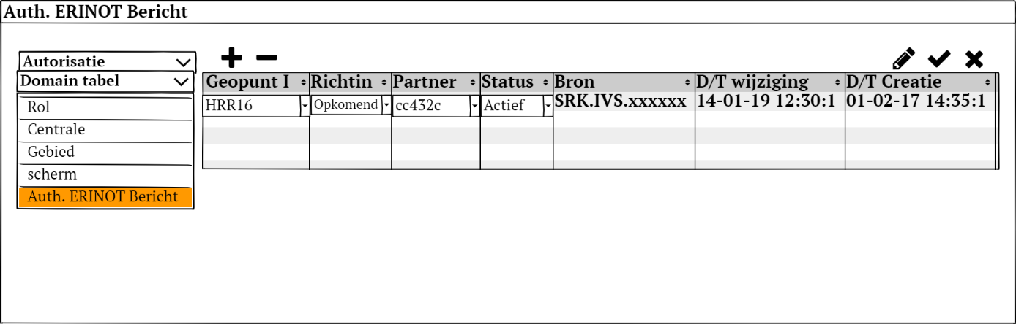

Figure 11; ERINOT Message Authorization Domain data edit screen layout



Table 11; ERINOT Message Authorization Domain data format

## Prioriteit Bron

This screen is used to define the Source entity for use in the Priority mechanism. There was a discussion about including a default priority. This is however not needed as there is a default priority defined in 7.12 below where there is a catchall record. Editing is done in the details area

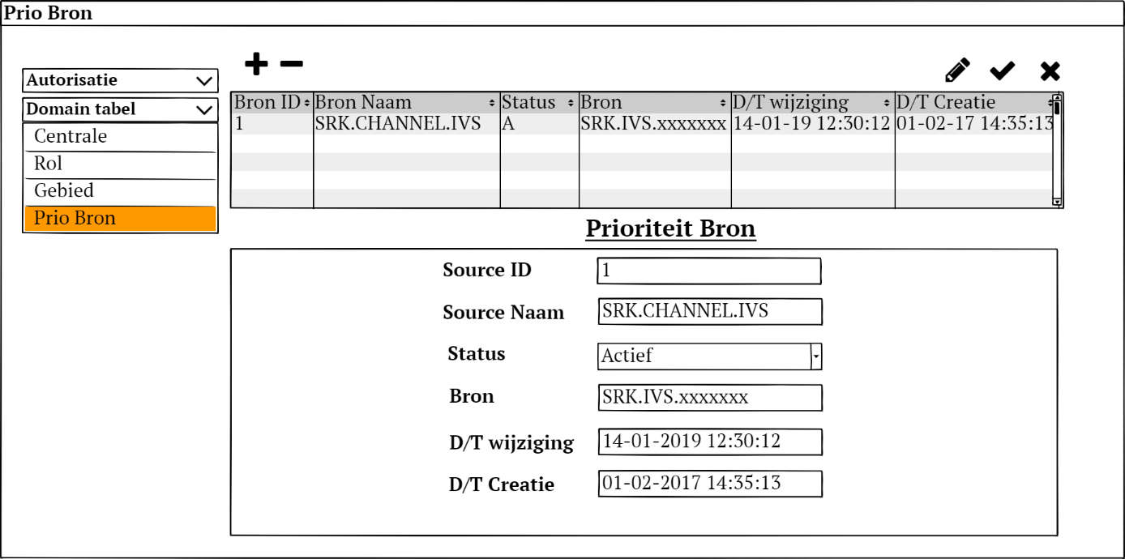

Figure 12; Priority Source Domain data edit screen layout



Table 12; Priority Source Domain data format

## Data Element Prioriteit

This screen is used to determine the priority that message sources get when providing data input. For each Data element we can set for each Source whet priority the source gets in setting the value in the system. Editing is done in the table area. To ease editing we have a filter on data element.

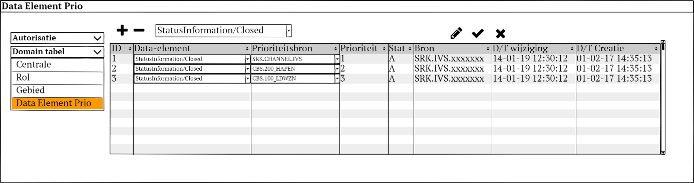



## Enumeraties

This screen is used to maintain the various LOV enumerations used in the system. For a specification of the fields in the table section and the details section I refer to the “Centre” tab in the accompanying Excel sheet.

Editing is done in the details area. Because of the large number of different enumerations that can be maintained here it is possible to filter for a specific type.

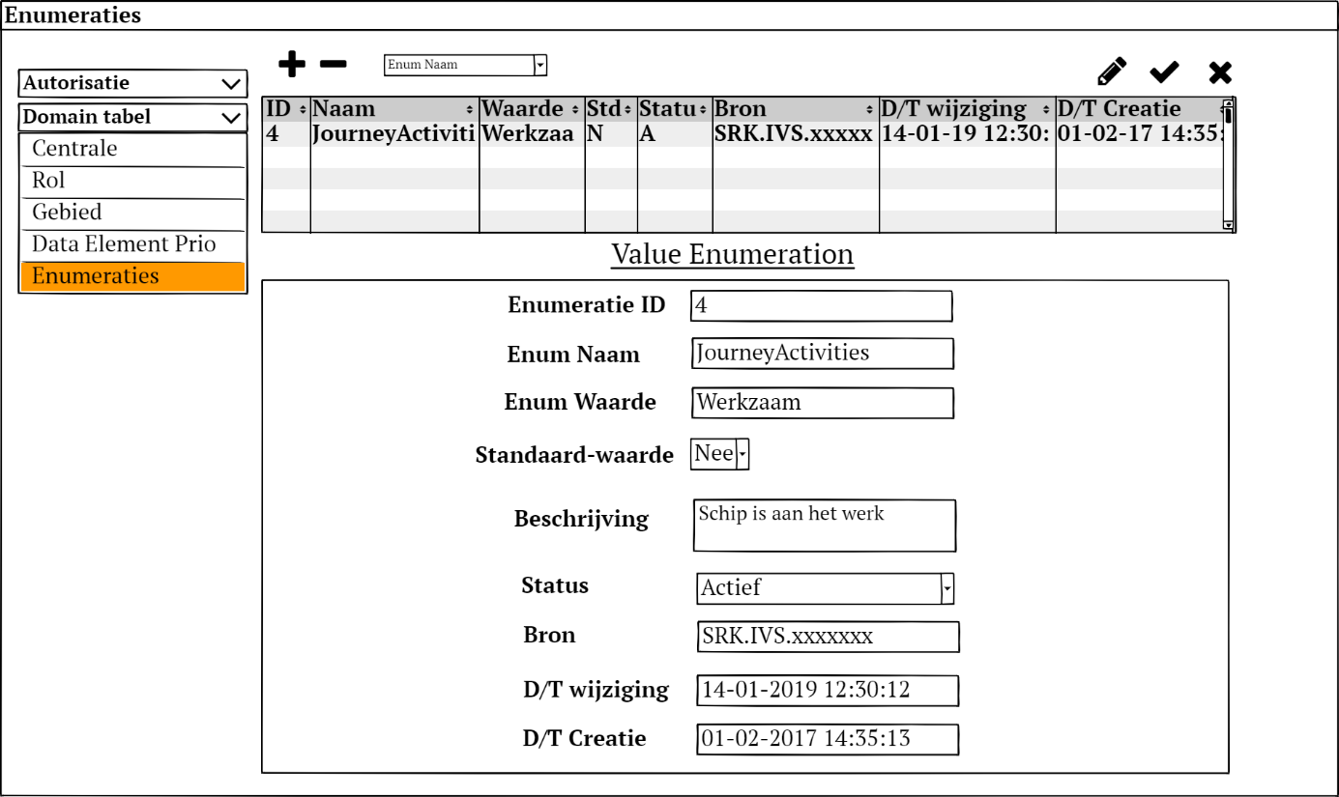

Figure 13; Enumerations Domain data edit screen layout



Table 13; Enumerations Domain data format

## Timer

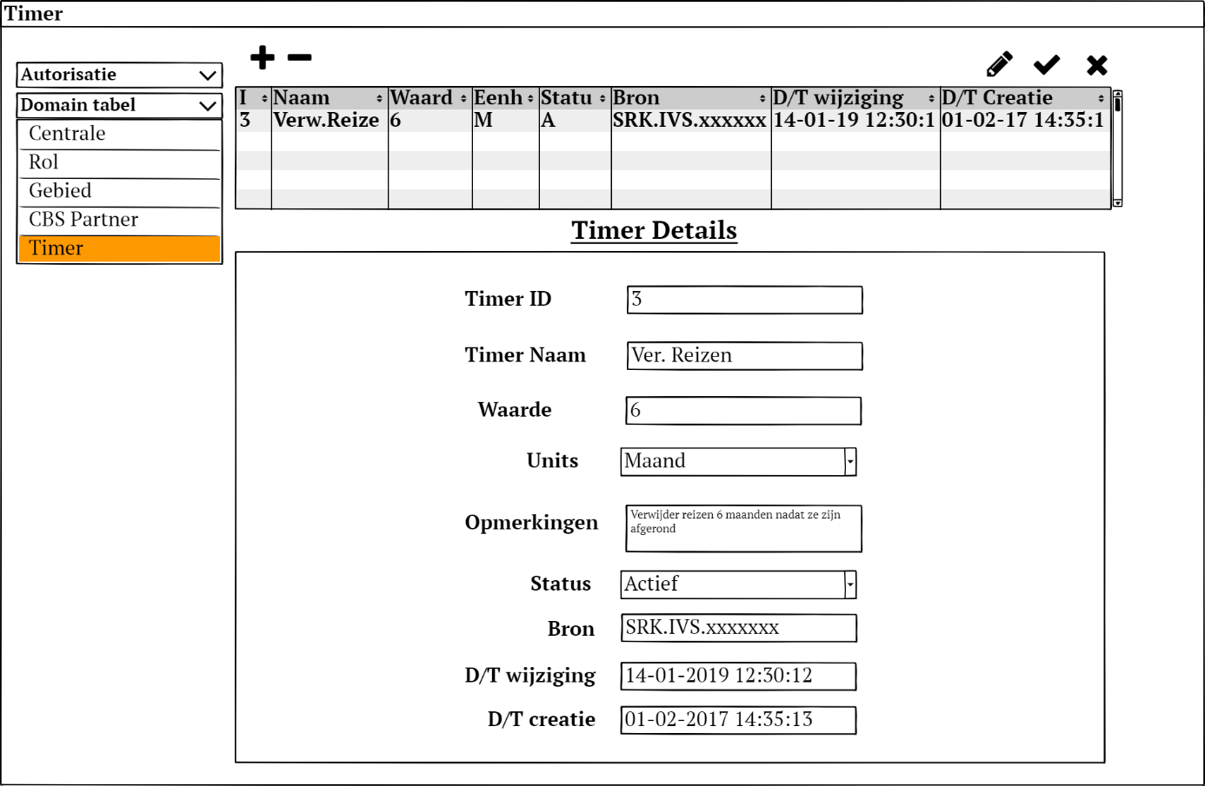

Table 14; Timer Domain data edit screen layout



Table 15; Enumerations Domain data format